Lab 08
4.1.
A) On which port number(s) does FTP communicate?
20 and 21

B) Which command can we use for filtering a given service name?
Grep
4.2.
A) How many Wireshark filter types do you know? Name them.
- Protocol Filters:
  - These filters allow you to focus on specific network protocols. For example:
    - ip: Displays all packets containing the IP protocol.
    - tcp: Shows only TCP packets.
    - udp: Filters UDP packets.
- Field Filters:
  - You can filter packets based on specific fields within protocols. Examples include:
    - ip.addr == 192.168.1.1: Filters packets with the source or destination IP address of 192.168.1.1.
    - tcp.port == 80: Displays packets using port 80 (HTTP).
- Logical Operators:
  - Combine filters using logical operators:
    - and: Requires both conditions to be true.
    - or: Requires at least one condition to be true.
    - not: Negates a condition.
- Comparison Operators:
  - Use these to compare field values:
    - == (equal)
    - != (not equal)
    - > (greater than)
    - < (less than)
    - >= (greater than or equal to)
    - <= (less than or equal to)
- Existence Filters:
  - Check if a field or protocol exists:
    - tr.rif: Filters packets containing the Token-Ring RIF field.

B) How can we make a diagram-based statistical report with Wireshark regarding the captured packets?
- Capture File Properties:
  - To get general information about the data captured over the network, follow these steps:
    - Start Wireshark.
    - Click on Statistics in the main menu.
    - Choose Capture File Properties.
  - In the Capture File Properties window, you’ll find details such as:
    - File: Provides file data (filename, path, length, etc.).
    - Time: Start time, end time, and duration of capture.
    - Capture: Hardware information for the PC where Wireshark is installed.
    - Interfaces: Interface information (registry identifier, interface type, packet size limit).
    - Statistics: General capture statistics, including captured and displayed packets1.

- Protocol Hierarchy:
  - To analyze the protocol distribution in the captured file, follow these steps:
    - Start Wireshark.
    - Click on Statistics.
    - Choose Protocol Hierarchy.
  - The Protocol Hierarchy window displays:
    - Protocol: The protocol name.
    - Percent Packets: The percentage of protocol packets from the total captured packets.
    - Packets: The number of protocol packets.
    - Percent Bytes: The percentage of protocol bytes from the total captured packets.
    - Bytes: The number of protocol bytes

- Flow Graph:
  - The Flow Graph window shows connections between hosts, including packet time, direction, ports, and comments for each captured connection.
  - You can filter connections by ICMP Flows, ICMPv6 Flows, UIM Flows, and TCP Flow
  - 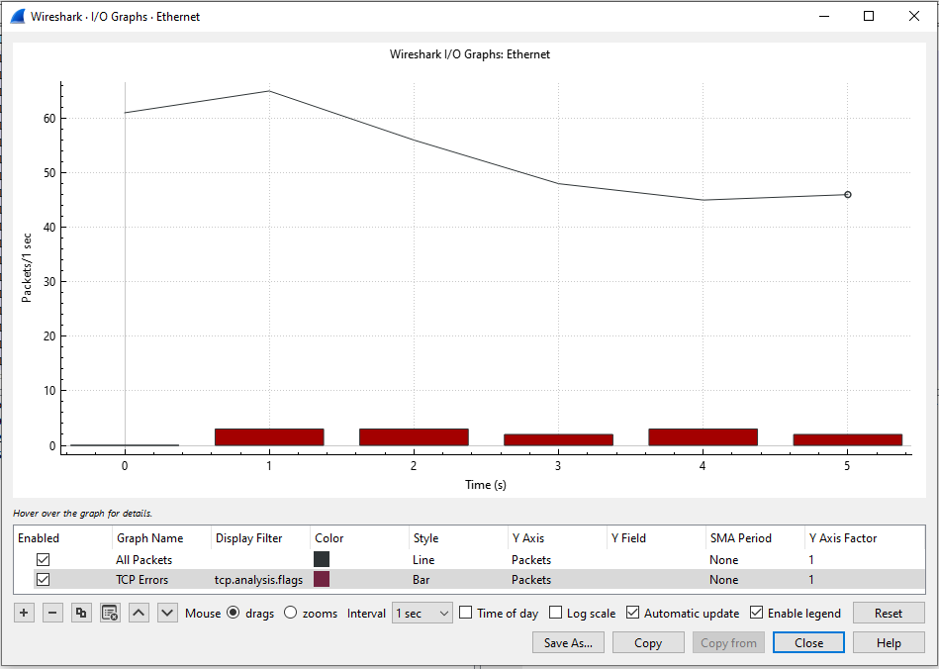
4.3.
a) How many system states does the Finite State Machine (FSM) contain which manages TCP connection?
The Finite State Machine (FSM) that manages a TCP connection typically consists of six primary states. These states represent different phases of the connection lifecycle:
- Closed: The initial state when no connection exists.
- Listen: The server is waiting for incoming connection requests.
- Syn-Sent: The client initiates a connection by sending a SYN packet.
- Syn-Received: The server acknowledges the client’s SYN packet and sends its own SYN packet.
- Established: The connection is fully established, and data transfer can occur.
- Close-Wait: The server has received a request to close the connection but is waiting for any remaining data to be sent.
- Last-Ack: The server acknowledges the client’s request to close the connection.
- Time-Wait: A final state where the server waits for any delayed packets before fully closing the connection.
B) What is the difference between an active and a passive TCP connection termination?
- Active Termination (Client-Side):
  - In an active termination, the client (initiator of the connection) actively initiates the termination process.
  - The steps involved in active termination are as follows:
    - The client sends a FIN (Finish) packet to the server, indicating that it has finished sending data.
    - The server acknowledges the FIN packet with an ACK (Acknowledgment).
    - The server may continue to send any remaining data it has.
    - Once the server is done, it sends its own FIN packet to the client.
    - The client acknowledges the server’s FIN packet.
    - The connection transitions to the TIME-WAIT state for a brief period before fully closing.
- Passive Termination (Server-Side):
  - In passive termination, the server (receiver of the connection) passively waits for the client to initiate termination.
  - The steps involved in passive termination are as follows:
    - The server receives a FIN packet from the client.
    - The server acknowledges the FIN packet with an ACK.
    - The server may continue to send any remaining data it has.
    - Once the server is done, it sends its own FIN packet to the client.
    - The client acknowledges the server’s FIN packet.
    - The connection transitions to the TIME-WAIT state.
- TIME-WAIT State:
  - Both active and passive terminations end up in the TIME-WAIT state.
  - This state ensures that any delayed packets related to the terminated connection are handled correctly.
  - After a brief period (usually a few minutes), the connection is fully closed.
4.4
A)Can we use netstat command in Windows environment?
yes

B) How (using which command and what way) can we determine if we have an active web connection with destination host IP address 193.225.40.94?
netstat -aon | findstr ":80" (in command prompt)

4.5
A) Can we use the netcat tool for implementing a chat program?
- Create the Listener:
  - On d1, run the following command to set up Netcat as a listener on a specific port (e.g., port 1234):
  - nc -nvlp 1234
    - Flags used:
      - -n: Do not resolve hostnames via DNS.
      - -v: Set verbosity level (verbose).
      - -l: Bind and listen for incoming connections.
      - -p: Specify the source port to use.
- Connect to the Listener:
  - On the other device (let’s call it d2), run the following command to connect to the listener on d1 using the IP address you noted down earlier:
  - nc <localhost_IP> 1234
Replace <localhost_IP> with the actual IP address from step 2.
- Chat Away!:
  - Now you have a simple chat set up between d1 and d2 using Netcat!

B) How could we block the running of such a chat environment in the most simple way?
- Network Firewall or Proxy Rules:
  - Configure your network firewall or proxy to block traffic on the specific port used by the chat program (e.g., port 1234 for Netcat).
  - Deny incoming and outgoing connections on that port to prevent communication.
- Application Whitelisting/Blacklisting:
  - Use application control or whitelisting/blacklisting tools to manage which applications are allowed to run.
  - Blacklist Netcat or any other chat-related tools to prevent their execution.
- User Access Control:
  - Limit user permissions to execute specific programs.
  - Ensure that only authorized users can run chat programs.
4.6.
A) Can file transfer happen above UDP?
yes
B) In the case of Netcat-based file transfer is server or client side necessary to implement first? Justify your answer.
In the context of Netcat-based file transfer, the server side should be implemented first. Let me explain why:
- Server-Client Model:
  - Netcat operates using a client-server model.
  - The server listens for incoming connections, while the client initiates connections to the server.
  - In file transfer scenarios, the server acts as the receiver of files, and the client sends the files.
- Order of Execution:
  - To establish communication, the server must be ready to accept incoming connections.
  - If the client is implemented first, it won’t have anywhere to send data until the server is up and running.
  - Therefore, implementing the server side first ensures that the communication channel is available when the client connects.
- Steps for Implementation:
  - Here’s the typical order of steps:
    - Server Side:
      - Set up the server using Netcat to listen on a specific port.
      - Example: nc -nvlp 1234
    - Client Side:
      - Connect the client to the server using the server’s IP address and port.
      - Example: nc <server_IP> 1234
    - File Transfer:
      - Once the connection is established, the client can send files to the server.
- Justification:
  - Implementing the server side first ensures that the communication infrastructure is ready before clients attempt to connect.
  - It prevents potential issues where clients connect to a non-existent server.
  - Additionally, it follows the natural flow of communication establishment.
4.7.
A) Which option can we use for setting the scanned server side in listening mode?
nc -l 4444
B) Can we use the netcat tool for scanning several ports which are opened at the same time?
nc -zvn google.com 1-100

4.8.
A) Can we use nmap port for opening?
yes
B) Which port numbers are open on freemail.hu server?
nmap freemai.hu parancs segítségével:
Port | Státusz
25/tcp | Zárt
80/tcp | Nyitott
110/tcp | Nyitott
143/tcp | Nyitott
443/tcp | Nyitott
993/tcp | Nyitott
995/tcp | Nyitott

